The Transfiguration of Our Lord

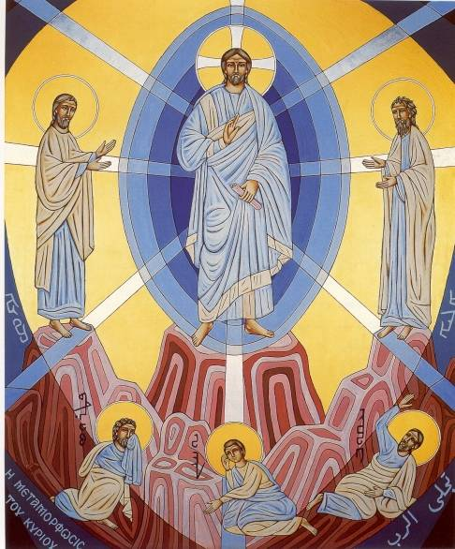

Saint Rafka Maronite Church
Greer, SC

Published Liturgical Year 2019

LIGHTING HYMN
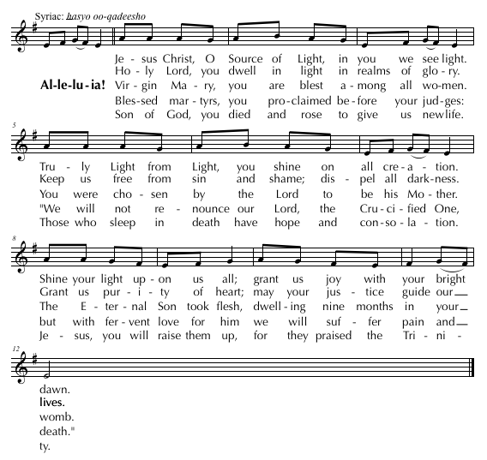

ENTRANCE HYMN
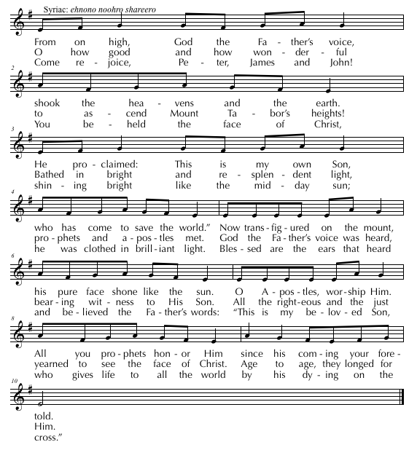

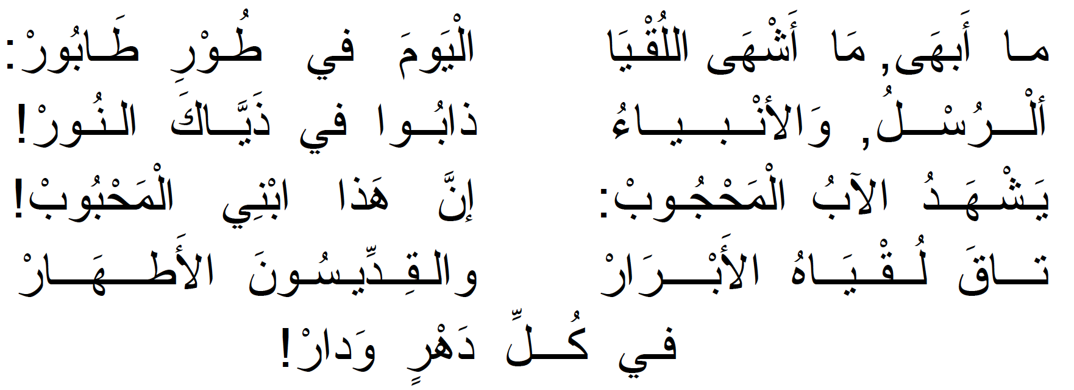
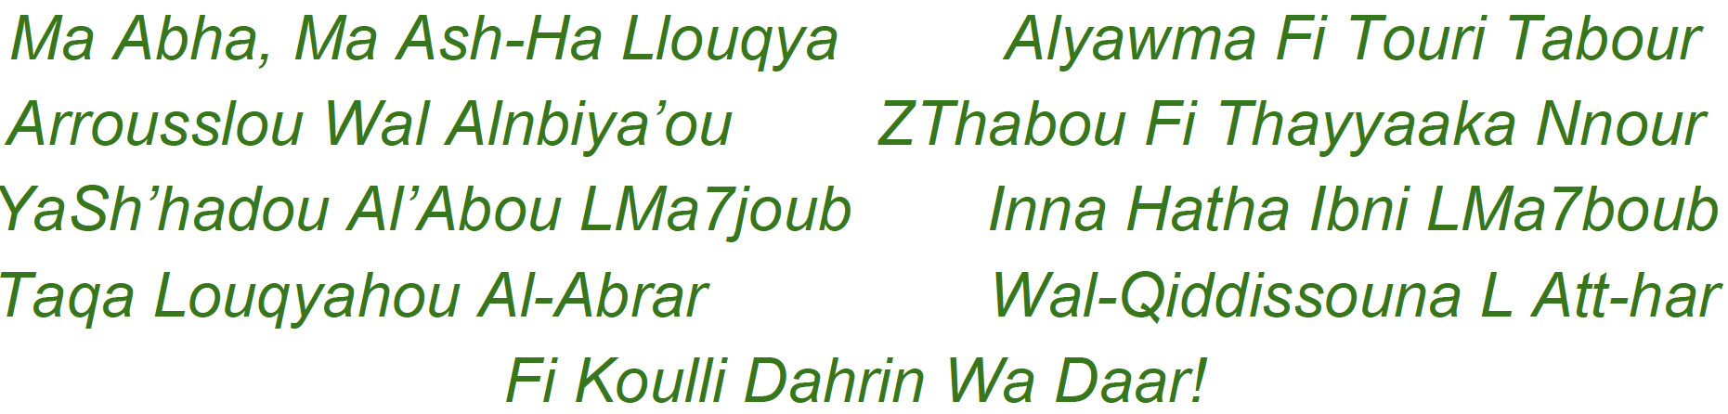

ENTRANCE DIALOGUE

Cel: I have entered your house, O God, and have worshiped before your throne. O King of heaven, forgive all my sins. O King of heaven, forgive all our sins.

Cel: Pray to the Lord for me. May the Lord accept your offering and have mercy on us through your prayer.

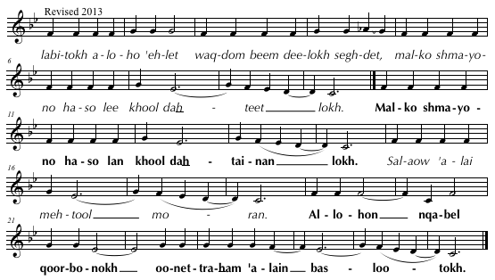

DOXOLOGY

Cel: Glory  be to the Father and to the Son and to the Holy Spirit, now and forever. Amen.

OPENING PRAYER

Cel: O Lord God, make us worthy to celebrate this feast of our salvation, this feast of joy
and spiritual happiness, this feast of your transfiguration on the mountain top, with purity and holiness, with heavenly praises, and with hymns of the Holy Spirit. Enable us to offer at all times praise of triumph and voices of thanks to you, O Christ, your Father, and your Holy Spirit, now and forever. Amen.

GREETING AND HYMN OF THE ANGELS

Cel: Peace  be with the Church and her children.

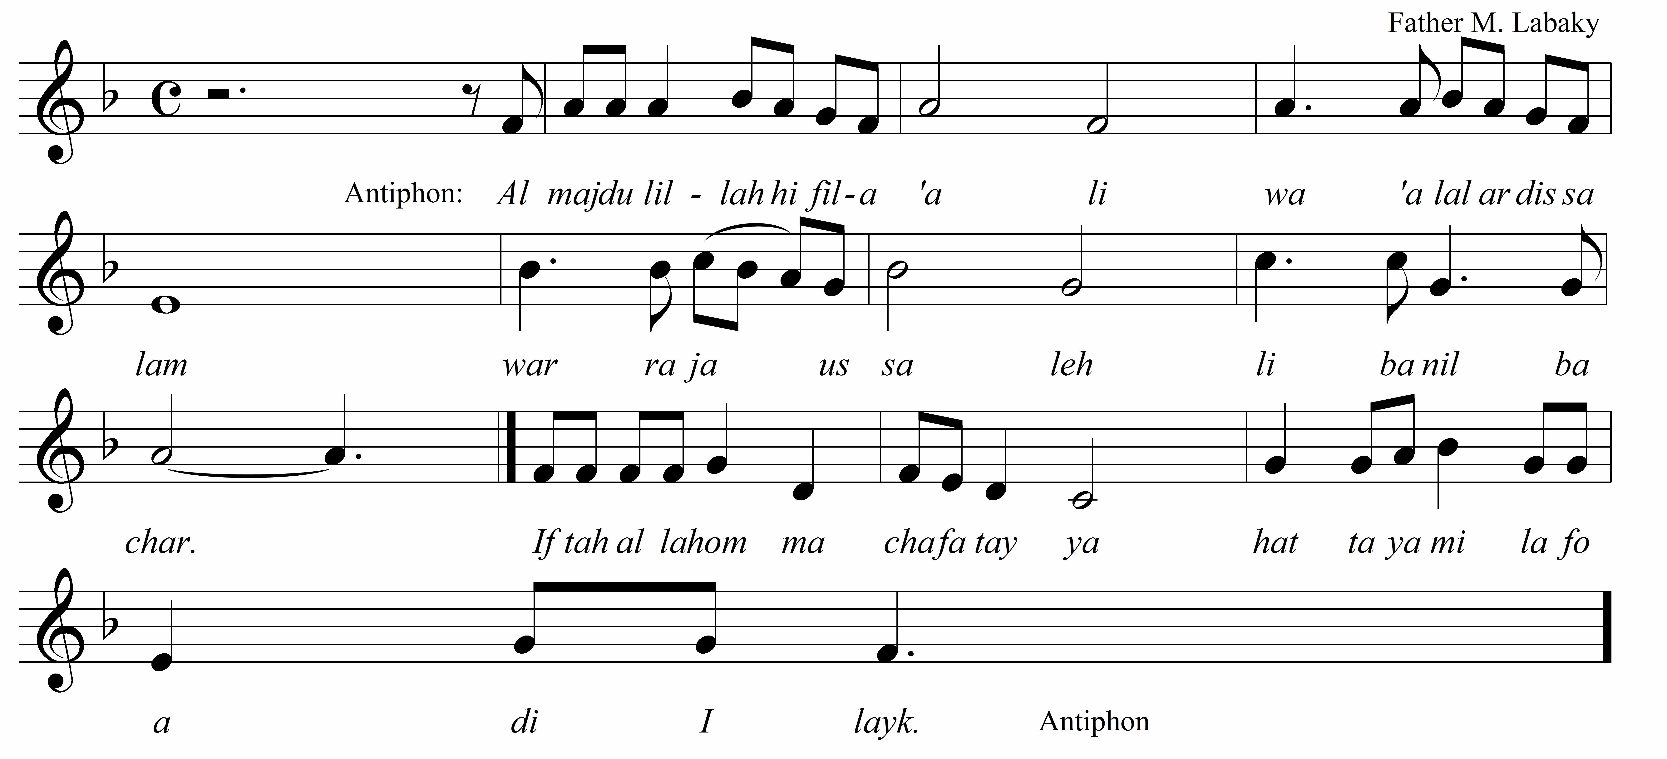

HOOSOYO
PROEMION

Please stand.

To the glory and honor of the Most  Holy Trinity.
Cel: May we be worthy to praise, glorify, and honor Jesus Christ the bright and ineffable Light and brilliance of the eternal Father; the glorious image of God, who revealed to us the three-fold mystery of God, the Most High. Today Christ manifests himself on Mount Tabor, shows his disciples the glory of his nature, and confirms them by the appearance of his majesty. To Christ, the good One, are due glory and honor, on this feast and all the days of our lives, now and forever. Amen.

SEDRO (May be sung in Arabic – English Translation)

Cel: O Christ our God, you are worshiped and glorified by the heavenly hosts. You chose to fulfill your plan of salvation for us and, in your wisdom, you submitted yourself to human birth and baptism. Before you carried out your saving sufferings on the cross, you led your disciples to Mount Tabor. You selected Peter, James, and John to be your witnesses and you were transfigured in their presence. In the bright splendor of your glory you were transformed before their eyes; you were cloaked in a dazzling spiritual cloud. The Father’s voice was then heard, saying: “This is my beloved Son. Listen to him!”

The disciples did not know what they were saying when they declared: “It is good for us, Lord, to make three dwellings here, one for you, one for Moses and one for Elijah.” In your might, you lifted their spirits and enlightened their hearts. You cautioned them not to reveal the mysterious vision until your passion was over.

Now we beseech you, good Lord: bathe your Church in your great light and confirm us on the foundation of the true faith. Exalt your Christian people and, in your mercy, forgive their sins. Grant good memory to their faithful departed. We glorify and thank you, O Christ, your Father, and to your Holy Spirit, now and forever. Amen.
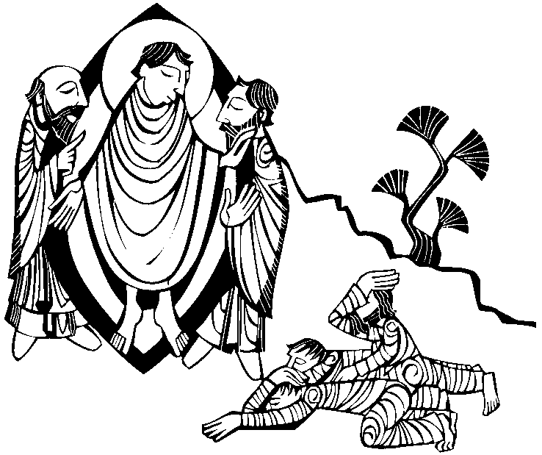
QOLO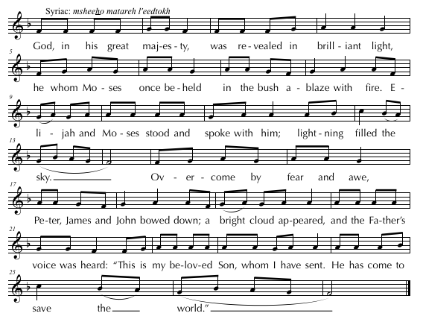
ETRO
Cel: O Lord God, grant us to honor, with good deeds and holy acts, the feast of the revelation of your divinity in three Persons. Make us worthy to find mercy and compassion from the treasure of your wealth, to ascend in spirit the mountain of your divinity, to dwell in the bright abode of your majesty, and to praise your eternity, O Father, Son and Holy Spirit, now and forever. Amen.

TRISAGION
The congregation stands and the Trisagion is then sung three times.
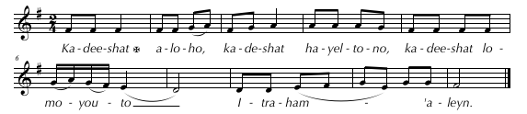
Holy God! Holy Mighty One! Holy Immortal One, have mercy on us!
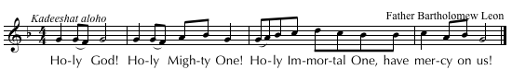

Cel: Holy and immortal Lord, sanctify our minds and purify our consciences, that we may praise you with purity, and listen to your Holy Scriptures. To you be glory, forever. Amen.

The congregation is now seated.

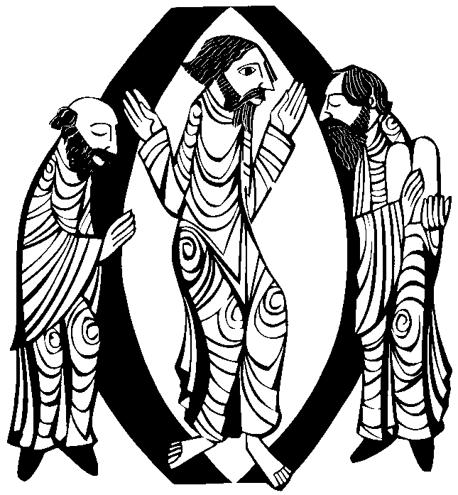
SERVICE OF THE WORD

MAZMOORO

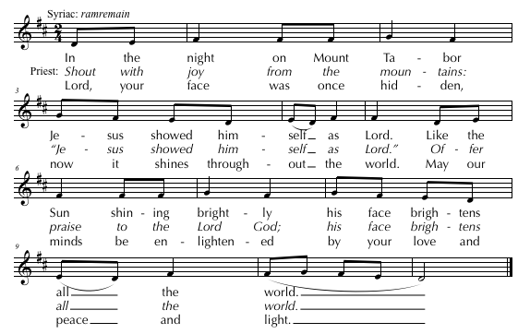
Ihtifi Ya Shou3oubou Washdi-L7amda Libni Llah
Wafra7i Ya Qouloubou Wajhal Fadee Ma Abha-ah
SCRIPTURE READING
Lector: A reading from…. Your blessing, Father.

Cel: Glory to the Lord of Paul and the apostles!  May the mercy of God descend upon the reader and the listeners, and upon this parish and her children, forever.
The appointed Scripture Reading of the Day, 2 Cor. 3: 7 - 17, is proclaimed by the lector.

Cantor: Praise be to God, always!

The congregation now stands.

FETGOMO (Gospel Acclamation)

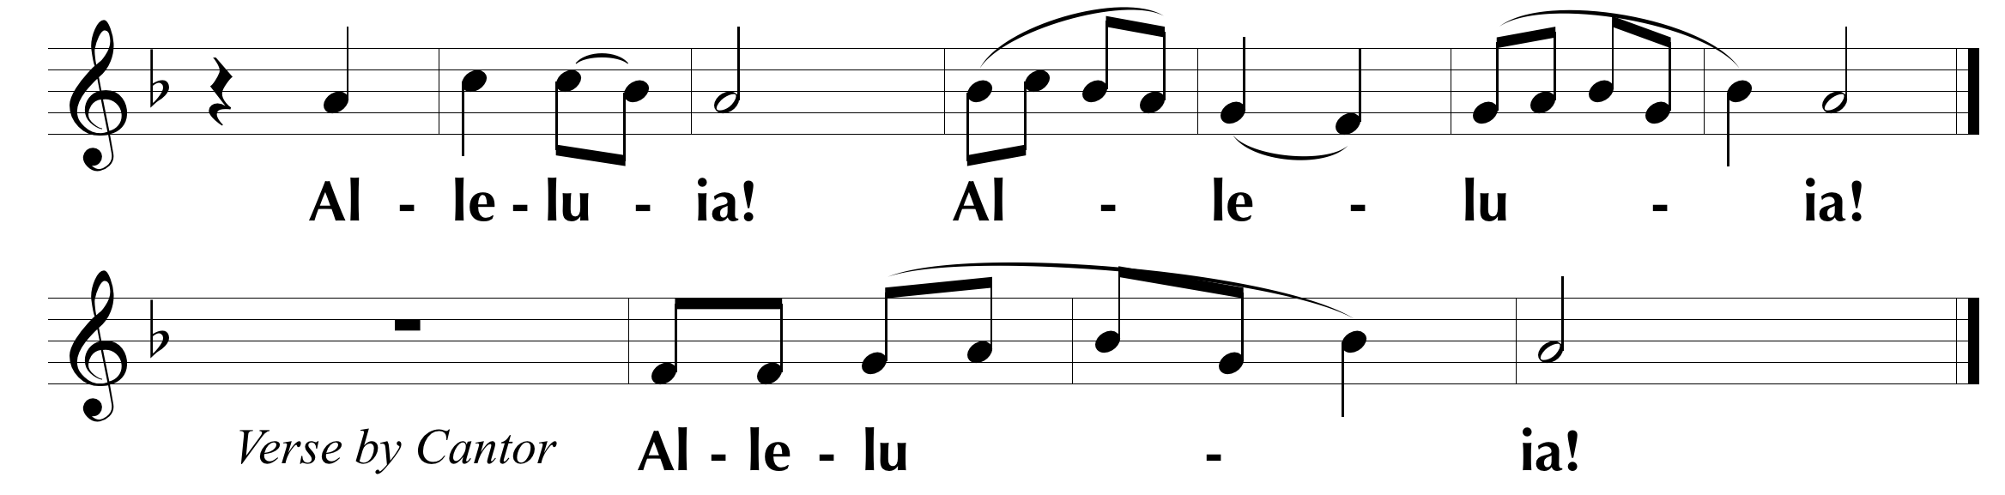

“Lord, it is good for us to be here and to make three dwellings:
one for you, one for Moses and one for Elijah.” (Matthew 17:4)

GOSPEL

Deacon/Cantor: Before the proclamation of the Gospel of our Savior, announcing life for our souls, we offer this incense, and ask for your mercy, O Lord.

The celebrant burns incense.

Cel: Peace  be with you. And with your Spirit.

From the Gospel of our Lord Jesus Christ according to Saint N, who proclaimed life to the world. Let us listen to the proclamation of life and salvation for our souls.

The celebrant incenses the Book of Gospels three times. Meanwhile, the deacon proclaims:

Deacon/Cantor: Remain silent, O listeners, for the Holy Gospel is about to be proclaimed to you. Listen, and give glory and thanks to the Word of the living God.

The celebrant begins the gospel, Mark 9:1 - 7, using the appropriate words. At the conclusion of the gospel, he sings or says:

Cel: This is the Truth,  Peace be with you!

KOROZOUTO (Acclamation of Praise)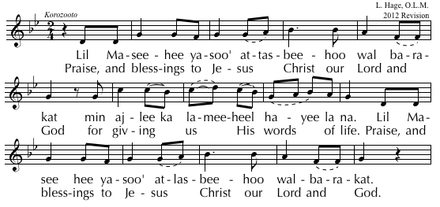

Homily

COLLECTION

Profession of Faith

We believe  in one God, the Father almighty, maker of heaven and earth, of all things visible and invisible.

We believe in one Lord Jesus Christ, the only-begotten Son of God, born of the Father before all ages. God from God, Light from Light, true God from true God, begotten, not made, consubstantial with the Father; through him all things were made. For us men and for our salvation he came down from heaven, and by the Holy Spirit was incarnate of the Virgin Mary, and became man.

For our sake he was crucified under Pontius Pilate, he suffered death and was buried, and rose again on the third day in accordance with the Scriptures. He ascended into heaven and is seated at the right hand of the Father. He will come again in glory to judge the living and the dead and his kingdom will have no end.
We believe in the Holy Spirit, the Lord, the giver of life, who proceeds from the Father and the Son, who with the Father and the Son is adored and glorified, who has spoken through the prophets.

We believe in one, holy, catholic, and apostolic Church. We confess one Baptism for the forgiveness of sins and we look forward to the resurrection of the dead and the  life of the world to come. Amen.

Access to the Altar

Cel: I will go to the altar of God, to God who gives joy to my youth. Through the abundance of your goodness I will enter your house and worship in your holy temple. Guide me, O Lord, in your fear, and instruct me in your justice.

Ee-tel-wot ma-deb-hed a-lo-ho wal-wot a-lo-ho dam-ha-deh tal-yoot. weh-nob soo- ghod tai-boo-tokh eh-‘ool-lel bai-tokh wes-ghood-deb hai-yek-lod qood-shokh. Bdeh-hel-tokh mor-yo da-ba-rain wab-za-dee-qoo-tokh a-leh-fain.

Cel: Pray to the Lord for me. May the Lord accept your offering and have mercy on us through your prayer.

Sa-laow ‘a-lai meh-tool mo-ran. A-lo-hon qa-bel qoor-bo-nokh ^{oo}-net-ra-ham ‘a-lain bas-loo-tokh.
Transfer of the Offerings
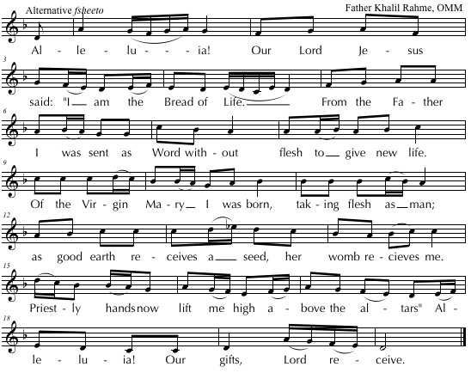
Acceptance of the Offerings

Cel: Almighty Lord and God, you accepted the offerings of our ancestors. Now accept these offerings that your children have brought to you out of their love for you and for your holy name. Shower your spiritual blessings upon them and, in place of their earthly gifts, grant them life and your kingdom. Amen.

Commemorations

Cel: As we remember our Lord God and Savior Jesus Christ, and his plan of salvation for us, we recall upon this offering all those who have pleased God from Adam to this day, especially Mary, the blessed Mother of God, Saint Maron, Saint Rafka, (and Saint(s) N. (of the day).

Remember, O God, the children of the holy Church: our fathers and mothers, and our brothers and sisters, both the living and the departed, especially those for whom this sacrifice is offered, N. Remember also all those who share with us today in this offering. Amen.
Incensation of the Offerings
May also be sung in Syriac.
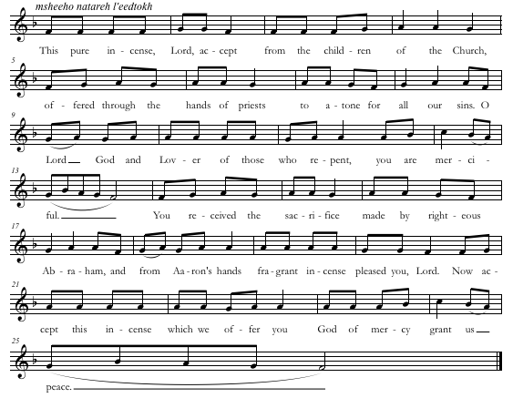
Anaphora of Saint Basil, Bishop of Caesarea

RITE OF PEACE

Doxology

The congregation stands.

Cel: Glory be ✠ to the Father, and to the Son, and to the Holy Spirit, now and forever. Amen.

Prayer for Peace

Cel: Eternal God, in the beginning You created man immortal. Your Son filled the world
with peace and destroyed death. Fill us with Your peace and cleanse us from sin that invites death. Let us greet one another in peace so that we may share in Your eternal legacy. With Christ Our Lord and the Holy Spirit, glory and honor are Yours, forever. Amen.

Exchange of Peace
Cel: Peace to you, O Altar of God. Peace to the holy mysteries placed upon you. Peace to you, O server of the Holy Spirit.

Diaconal Proclamation

Deacon: Let us give the greeting of peace to our neighbor with love and faith that are pleasing to God.

The people exchange the greeting of peace with joined hands.
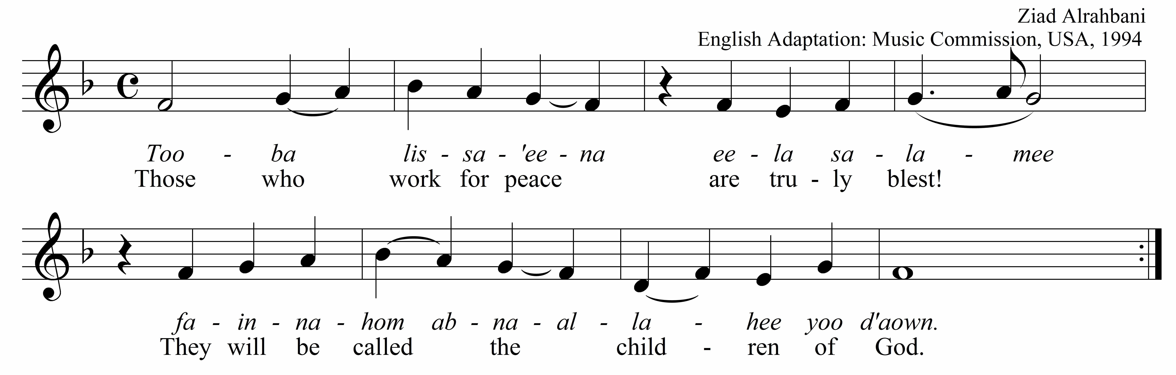

EUCHARISTIC PRAYER
Dialogue

Cel: The love of God the ✠ Father, and the grace of the only-begotten ✠ Son, and the communion and indwelling of the ✠ Holy Spirit be with you, my brothers and sisters, forever. And with your Spirit.

Cel: Let us lift up our thoughts, our minds, and our hearts. We lift them up to the Lord.

Cel: Let us give thanks to the Lord with reverence and worship him with humility. It is right and just.

Preface

Cel: Angels and archangels worship You. Thrones and dominations praise Your name. Seraphim and cherubim confess Your divinity. They chant the glories of our salvation, saying:

Hymn of Triumph

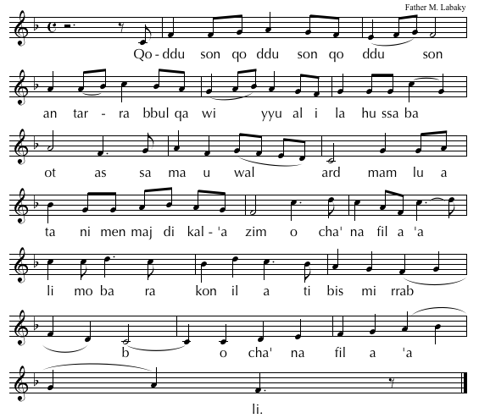
Cel: Lord, You are holy indeed; Your greatness is beyond measure. From the earth You formed us, and in Your image You framed us. But we would not hear the voice of our Creator, so the serpent deceived us. Even then You did not turn away from what You created in goodness, but You visited us with the refreshing spring of Your mercy. The child You sent healed us. He sought us out, and in various ways He called us. From ancient times He raised up righteous ones to remind us of Your truth. And although He was God from all time, He did not cling to His equality with God. He emptied Himself and became a servant. And since sin entered the world because of man, and through sin, death, Your Son chose to conquer sin in His own body, so that we who die because of Adam, should live because of Christ. He made us a people well-disposed, a priestly kingdom. He purified us with water, and sanctified us with the Spirit. He became a substitute for our death, with His resurrection He raised us all. He left us a memorial of His saving acts in this bread and wine which we have now set apart according to His command.

Institution Narrative

The Words of Institution of Our Lord are sung in Syriac.

Cel: Byow-mo how daq-dom ha-sho-dee-leh ma’-bed hy-eh nsa-bel-lah-mo be-dow qa-dee-sho-to. Ou-b-rek ou-qa-desh waq-so ou-ya-bel-tal-mee-dow kad o-mar. Sab-a-khool men-neh kul-khoon: Ho-no den ee-tow faghro-deel dah-lo-fy-koun wah-lof sagee-yeh meh-teq-she ou-meh-tee-heb lhoo-soyou dhow-beh wal-ha-yeh dal-‘o-lam ‘ol-meen.
(Translation) And on the day before his life-giving passion, He took bread in his holy hands. He blessed, sanctified, and broke it, and gave it to his disciples, saying: Take this, all of you, and eat of it, for this is my body which is broken and given for you and for many for the forgiveness of sins and for eternal life.
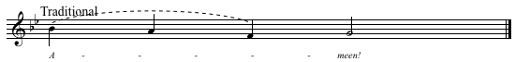

Cel: Ho-kha-no ‘al ko-so dam-zeegh wo man ham-ro ou-men ma-yo ba-reh ou-qa-desh ya-bel-tel mee-dow kad o-mar: Sah esh-tow meh-neh kul-khoon: Ho-no den ee-tow dmo deel dee-ya-tee-qee had-to Dah-lo-fy-koon wah-lof sa-gee-yeh Meh-the-shed ou-meh-tee heb. Lhoo-so-yo dhow-beh wal-ha-yeh Dal-o’lam ‘ol-meen.

In a similar way, over the chalice of wine mixed with water, he blessed and sanctified it, and gave it to his disciples, saying: Take this, all of you, and drink from it, for this is my blood of the new covenant, which will be poured out and given
for you and for many for the forgiveness of sins and for eternal life.
Anamnesis

Cel: Every time you do this, you will proclaim My death and recall My burial and
resurrection until I return. We remember your death, O Lord. We profess your resurrection. We await your second coming. We implore your mercy and compassion. We ask for the forgiveness of sins, and may your mercy rest upon us.

Cel: And now, O Lord, we commemorate Your saving plan for us. You became our
substitute to forgive the sin of the world. When You return to judge, do not turn Your people away to the kingdom of darkness. Deliver and rescue us, you You are merciful and abounding in compassion. Therefore, Your inheritance petitions You, and through You, the Father, saying: Have mercy on us, Almighty Father. Have mercy on us.

Cel: We, your poor and sinful servants, O Lord, realize the graces we have received and
thank you for them and because of them. We praise you. We bless you. We adore you. We glorify you. We profess our faith in you, and we ask you: Have compassion on us, O God, have mercy on us, and hear us.
Epiclesis

Deacon: How awesome is this moment, my beloved, for the living Holy Spirit descends and rests upon this offering for our sanctification. Let us stand with reverence as we pray:

Cel: (At the same time, silently and bowing, he flutters his hands three times over the Mysteries) O Lord, You have made us worthy to approach Your holy table, not because of our merits, but because of Your Son. We now draw near to the elements of the Body and Blood of Christ. We now petition You to send Your Holy Spirit upon us and upon these Mysteries to sanctify them.

The celebrant, kneeling on both knees, extends his hands and sings in English or in Syriac:

Cel: Hear us, O Lord. Hear us, O Lord. Hear us, O Lord. And may your living Holy Spirit come and rest upon us and upon this offering.

‘a-neen mor-yo. ‘a-neen mor-yo. ‘a-neen mor-yo. ^{oo}-nee-the mor roo-hokh ha-yo ^{oo}-qa-dee-sho. ^{oo-}na-gen ‘alain oº-‘al qoor-bo-no ho-no.

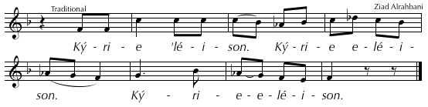

Cel: May the Holy Spirit reveal this bread ✠ to be the life-giving Body of Our Lord, Jesus Christ, for the forgiveness of sins and the eternal life of all who receive it.

Cel: And may He reveal this chalice ✠ to be the saving Blood of Our Lord, Jesus Christ, for the forgiveness of sins and eternal life of all who receive it.

Cel: May we who have been united by this living bread and saving ✠ cup be made worthy of the fellowship of the Holy Spirit. May our sharing in these Mysteries no condemn us, but may we find mercy on the day of judgment.
Intercessions

Congregation sits.

Cel: Lord, we offer You this sacrifice for Your holy churches throughout the world, especially your church here. Remember her faithful fathers, Francis, Pope of Rome, Beshara, Peter, our Patriarch of Antioch, Gregory, our Bishop. Grant them the wisdom and strength to shepherd Your people. We pray to you, O Lord.
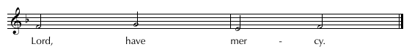
To each Intercession we respond:
The last Intercession is always:

Deacon: Remember the faithful who have left this life, (especially N.,) for whom we now pray. Grant them a gracious welcome at Your heavenly table. Grant rest, O God, to the departed, and forgive the sins we have committed, with or without full knowledge.

Cel: Most holy Lord, remember those whom we have recalled at Your holy altar today. Let us share in their inheritance and glorify You with one heart and one song of praise, forever. As it was, is now, and shall be forever. Amen.

COMMUNION RITE

Fraction, Signing, Sprinkling, Mingling, and Elevation
All stand and sing
Then all recite together:

O Lord, you are the pleasing Oblation who offered yourself for us. You are the forgiving Sacrifice who offered yourself to your Father. You are the High Priest, who offered yourself as the Lamb. Through your mercy, may our prayer rise like incense which we offer to your Father through you. To you be glory, forever.

Lord’s Prayer

Cel: O Lord, You have made us worthy to recall Your covenant with us. Teach us to serve You with sincerity and keep us united to Your Church, that we may pronounce these words Your Son taught us:

The celebrant and congregation extend their hands and pray in Arabic, Syriac, or English:

أبـانـا الذي في السماوات………...لأن لك الملك والقوة والمجد إلى أبد الآبدين آمين.

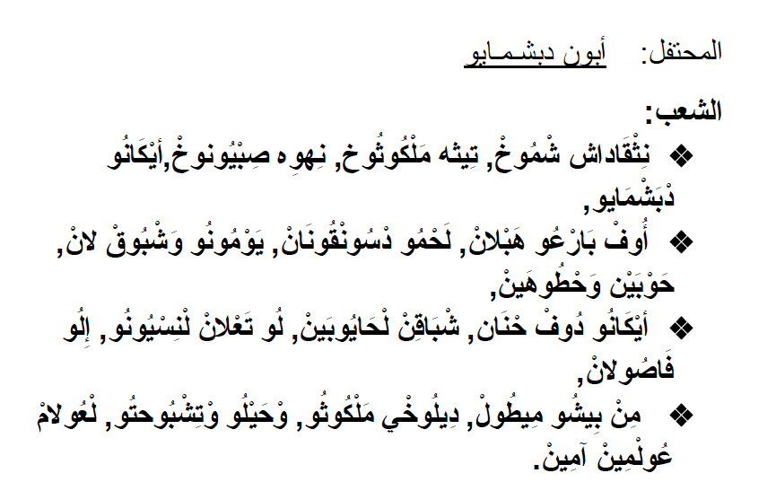
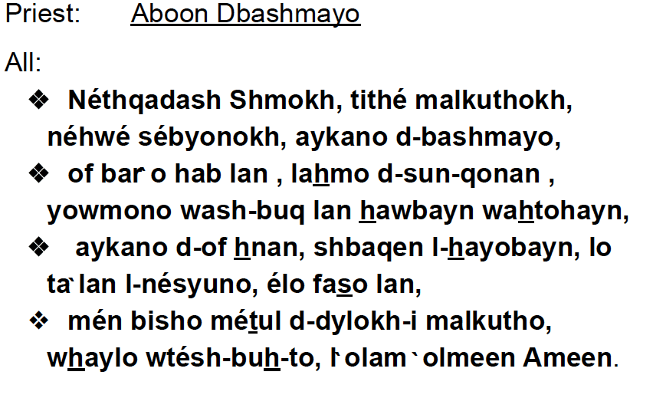

Cel: O Lord, save us from the devil’s deception, and remember the weakness of Your people. We look to You to sustain us at all times, forever. Amen.

Penitential Rite

Cel: Peace ✠ be with you. And with your Spirit.

Deacon: Bow your heads before the God of mercy, before his forgiving altar, and before the Body and Blood of our Savior, who gives life to those who partake of him, and receive the blessing of the Lord.

Meanwhile the priest prays quietly:

Cel: Merciful Father, You have made us worthy to stand before You and offer our
petitions. Now send us Your kind blessing that we may share in these life-giving Mysteries without guilt. Glory to you, now and forever. Amen.

Cel: The grace ✠ of the most Holy Trinity, eternal and consubstantial, be with you, my brothers and sisters, forever. And with your Spirit.
Deacon: Let us look to God with reverence and humility, and ask him for mercy and compassion.

Invitation to Communion

Cel: Holy Gifts ✠ for the holy, with perfection, purity, and sanctity.
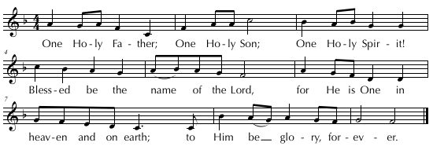
The celebrant and the congregation prepare for communion. They extend their hands in prayer and say:

Make us worthy, O Lord God, so that our bodies may be sanctified by your holy Body, and our souls purified by your forgiving Blood. May our communion be for the forgiveness of our sins and for new life. O Lord our God, to you be glory, forever.

Communion of the Clergy

Communion of the People

Communion is now distributed to the faithful. Communion is received by all on the tongue, not in the hand in the Maronite Church.

Guidelines for Receiving Holy Communion: For Catholics of any rite, to participate fully in the Eucharist, one should not be conscious of grave sin and normally have fasted for one hour. Members of the Orthodox Churches are welcome to receive communion if they are well disposed to do so. We welcome other Christians to our Divine Liturgy and share with you our common baptism, but, because of the sad divisions which separate us, members of those churches which we are not fully united are not admitted to Holy Communion.

Communion Hymns
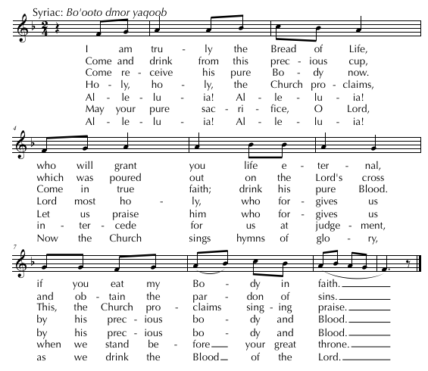

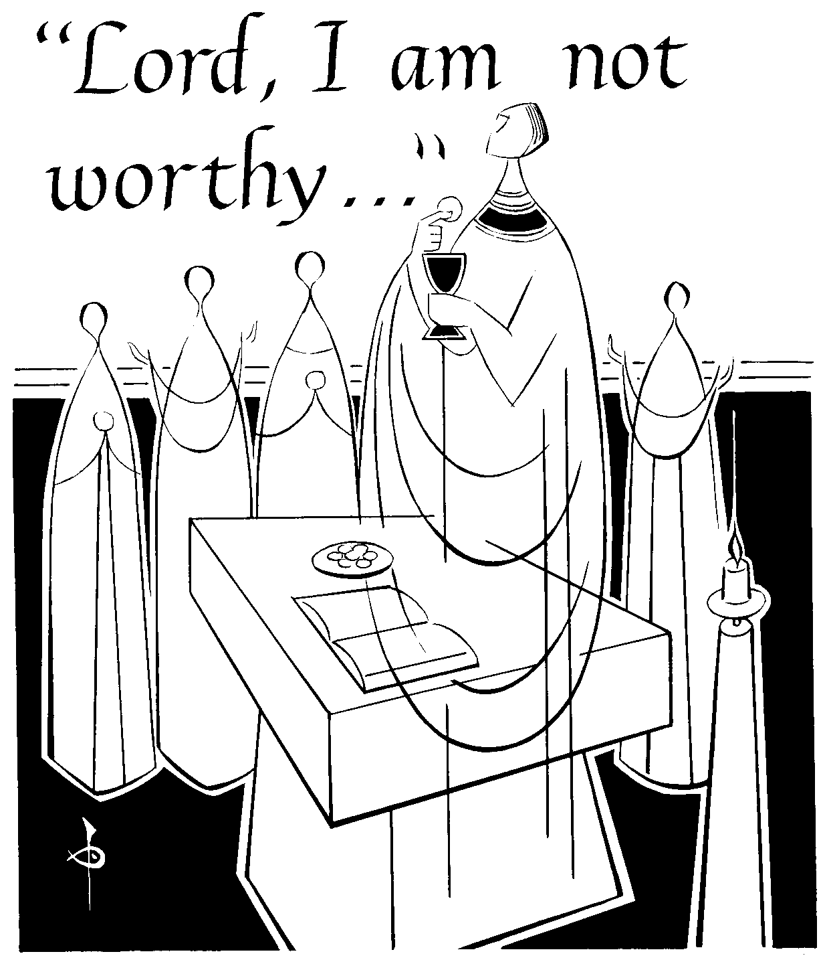
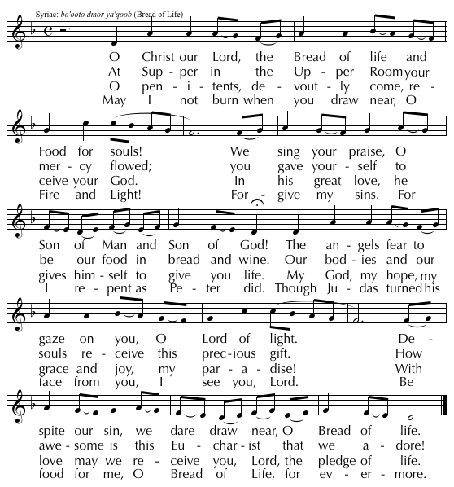

Other hymns may be sung.

Blessing with the Mysteries

After communion, the celebrant blesses the congregation with the mysteries.

Cel: Again and again we thank you, O Lord, and raise glory to you for giving us your Body to eat, and your living Blood to drink. O Lover of all people, have mercy on us. Have mercy on us, O Lord, O compassionate and merciful One, O Lover of all people, have mercy on us. Irhamna, Ya Rab’, Ya Hanoon, Ya Rahoom, Ya muhibban lil bashar irhamna إرحمنا يا رب, يا حنون, يا رحوم, يا محبّاً للبشر إرحمنا

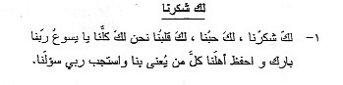

Laka Shoukrouna, Laka 7oubbouna, Laka Qalbouna, Na7nou laka Koullouna, Ya Yasou3 Rabbana

Barek Wa7hfaz Ahlana, Koullou Man You3na Bina, Wasstajib Rabbi Sou’lana

Benediction Hymn

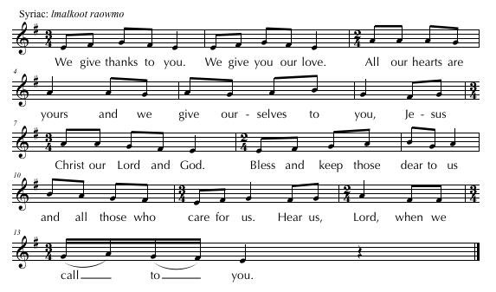

Thanksgiving Hymn
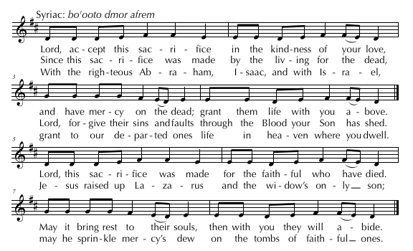
Thanksgiving

Cel: O Lord God, rest your invisible right hand upon us. With your saving cross, shelter all those who have received your holy body and blood. Strengthen your life-giving will among us. Establish true faith in you and grant us the power to keep your holy commands. Lead us to the banquet of the kingdom. With all your saints, we will praise you, your only-begotten Son and your Holy Spirit, now and forever.

Announcements

Cel: Peace ✠ be with you. And with your Spirit.

Cel: O God the Father, we bow before you and entrust ourselves to your care. We ask you, imploring your mercy, to rest your right hand, full of blessings, upon us. Assist us, protect us, bless us, and sanctify us by the cross of your only Son. We glorify and honor you, and your only Son, and your Holy Spirit, now and forever. Amen.

Final Blessing

Cel: Go in peace, my beloved brothers and sisters, with the nourishment and blessings you have received from the forgiving altar of the Lord. May the blessing of the Most Holy Trinity accompany you: the Father ✠, and the Son ✠, and the Holy Spirit ✠, the One God, to whom be glory, forever. Amen.

Concluding Hymn
1 'Tis good, Lord, to be here!
4 Before we taste of death,
We see Thy kingdom come;
We long to hold the vision bright,
And make this hill our home.

5 'Tis good, Lord, to be here!
Yet we may not remain;
But since you bidst us leave the mount,
Come with us to the plain.

Thy glory fills the night;
Thy face and garments, like the sun,
Shine with unborrowed light.

2 'Tis good, Lord, to be here,
Thy beauty to behold
Where Moses and Elijah stand,
Thy messengers of old.

3 Fulfiller of the past
And hope of things to be,
We hail Thy body glorified
And our redemption see.
Qurbono

The Book of Offering

The Service of the Holy Mysteries
According to the Antiochene Syriac Maronite Church

Qurbono: The Revised Book of Offering, © Copyright 2012 by the
Eparchy of Saint Maron of Brooklyn, Brooklyn, NY, USA

All rights reserved. No part of this publication may be reprinted in any form
or by any means without permission of the copyright owner in writing.

Qurbono with music format by Father Bartholomew Leon
Saint Rafka Maronite Mission
1215 S. Highway 14
Greer, SC 29650 864.469.9119

© 2017, Saint Rafka Maronite Catholic Church. All rights reserved.

Web site: www.saintrafka.org
Email: saintrafkagreenville@gmail.com

